Course Name | ITD 2343 – Object Oriented Programming with C#
Instructor | Mark L. Pranger
Student Name | Lauren Lashley
Due date | February 15, 2026
Grade | <grade earned here>
Grading Comments | <instructor comments here>

Week 6 – Programming Lab

Screenshot 1:
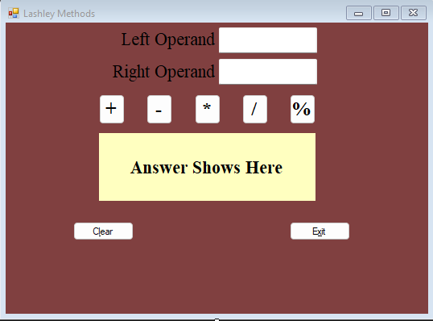

Screenshot 2:
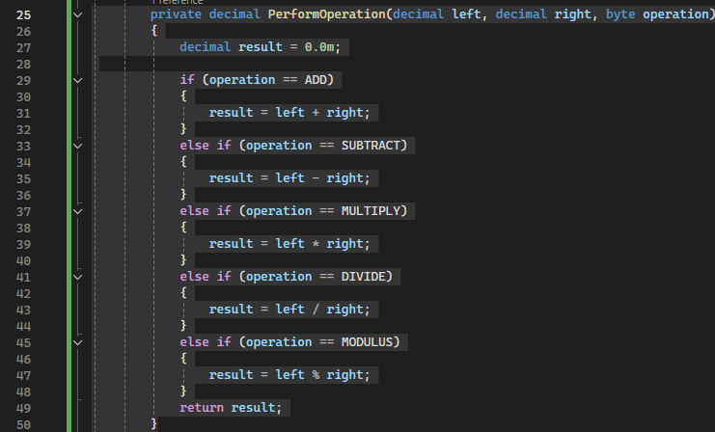

Screenshot 3:
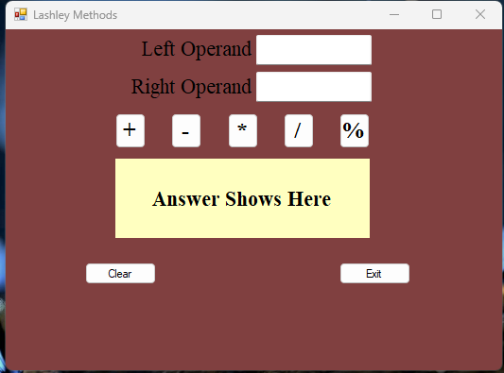

Screenshot 4:
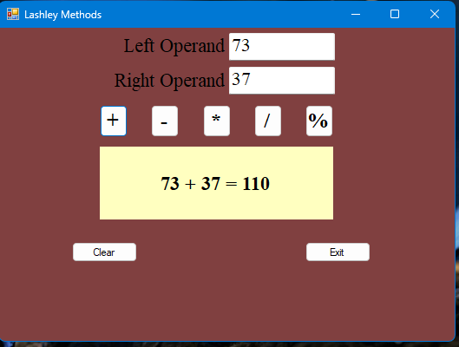

Screenshot 5:
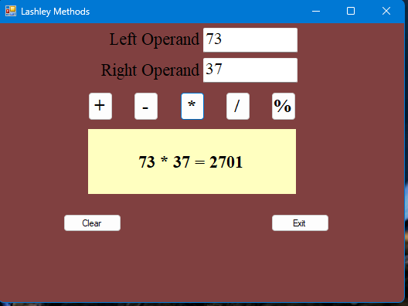

Screenshot 6:
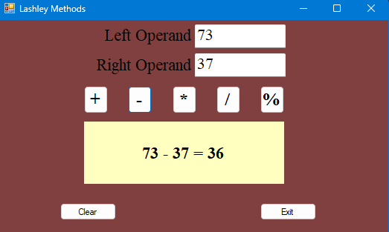

Screenshot 7:
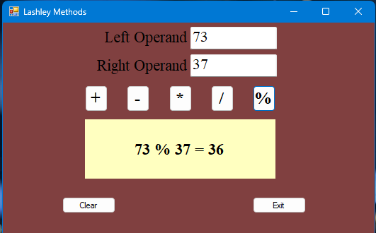
Screenshot 8:
